**ST. XAVIER’S COLLEGE**

**(Affiliated to Tribhuvan University)**

Maitighar, Kathmandu



**COMPUTER GRAPHICS**

**Lab Assignment #1**

**Submitted by:**

Saurav Bajracharya

013BSCCSIT035

**Submitted to:**

|  |  |
| --- | --- |
| **Er. Anil Sah**  **(Lecturer)** |  |
| **Department of Computer Science** | |

Draw the following checkbox:

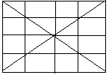

//---------------------------------------------------------------------------

#include <vcl\vcl.h>

#pragma hdrstop

#include "Unit1.h"

//---------------------------------------------------------------------------

#pragma resource "*.dfm"

TForm1 *Form1;

//---------------------------------------------------------------------------

__fastcall TForm1::TForm1(TComponent* Owner)

: TForm(Owner)

{

}

//---------------------------------------------------------------------------

void __fastcall TForm1::Button1Click(TObject *Sender)

{

Form1->Canvas->Pen->Width=3;

Form1->Canvas->Brush->Color=clWhite;

Form1->Canvas->Rectangle(10,10,300,300);

Form1->Canvas->MoveTo(10,10);

Form1->Canvas->LineTo(300,300);

Form1->Canvas->MoveTo(10,300);

Form1->Canvas->LineTo(300,10);

Form1->Canvas->MoveTo(10,152);

Form1->Canvas->LineTo(300,152);

Form1->Canvas->MoveTo(152,10);

Form1->Canvas->LineTo(152,300);

Form1->Canvas->MoveTo(10,76);

Form1->Canvas->LineTo(300,76);

Form1->Canvas->MoveTo(10,228);

Form1->Canvas->LineTo(300,228);

Form1->Canvas->MoveTo(76,10);

Form1->Canvas->LineTo(76,300);

Form1->Canvas->MoveTo(228,10);

Form1->Canvas->LineTo(228,300);

}

//---------------------------------------------------------------------------

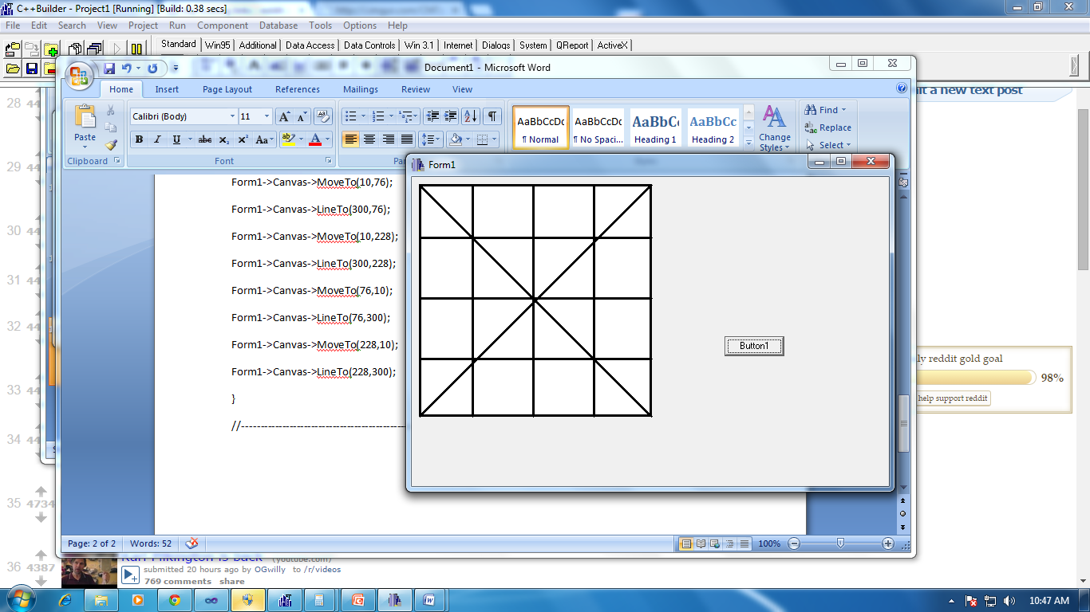

**CONCLUSION:**

Therefore, the checkbox can be drawn using c++ builder easily and systematically.